Student Name: Syed Aazmir Hussain
Roll No: 24K-0945
Instructor: Mr Mubashir
Lab No: 5
Subject: DLD Lab

POST LAB TASKS
Qs 1.
Logic Works Circuit Diagram

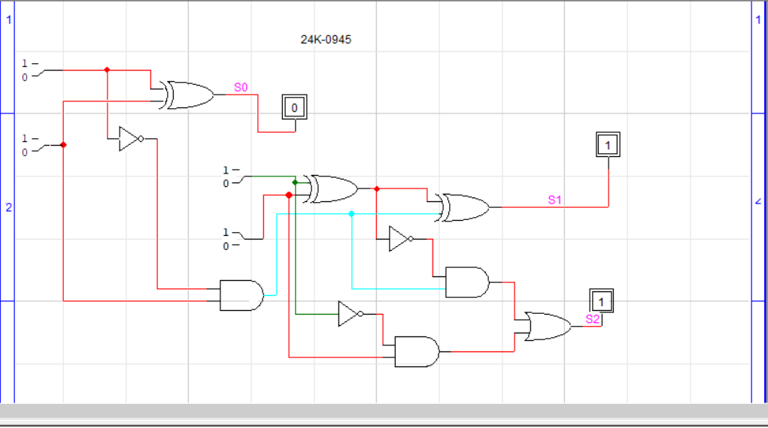

Truth Table
A1 | A0 | B1 | B0 | S0 | S1 | S2
0 | 0 | 0 | 0 | 0 | 0 | 0
0 | 0 | 0 | 1 | 1 | 1 | 1
0 | 0 | 1 | 0 | 1 | 0 | 1
0 | 0 | 1 | 1 | 0 | 1 | 1
0 | 1 | 0 | 0 | 0 | 1 | 0
0 | 1 | 0 | 1 | 0 | 0 | 0
0 | 1 | 1 | 0 | 1 | 1 | 1
0 | 1 | 1 | 1 | 1 | 0 | 1
1 | 0 | 0 | 0 | 1 | 0 | 0
1 | 0 | 0 | 1 | 0 | 1 | 0
1 | 0 | 1 | 0 | 0 | 0 | 0
1 | 0 | 1 | 1 | 1 | 1 | 1
1 | 1 | 0 | 0 | 1 | 1 | 0
1 | 1 | 0 | 1 | 1 | 0 | 0
1 | 1 | 1 | 0 | 0 | 1 | 0
1 | 1 | 1 | 1 | 0 | 0 | 0

Qs 2

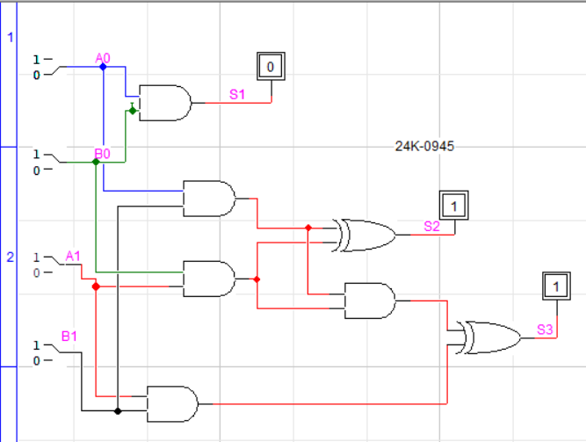
A1A0 | B1B0 | S3 | S2 | S1 | Decimal
10 | 11 | 1 | 1 | 0 | 6

10
X1 1
10
10 x
=(110)2 = 4 + 2 = 6
Qs 3

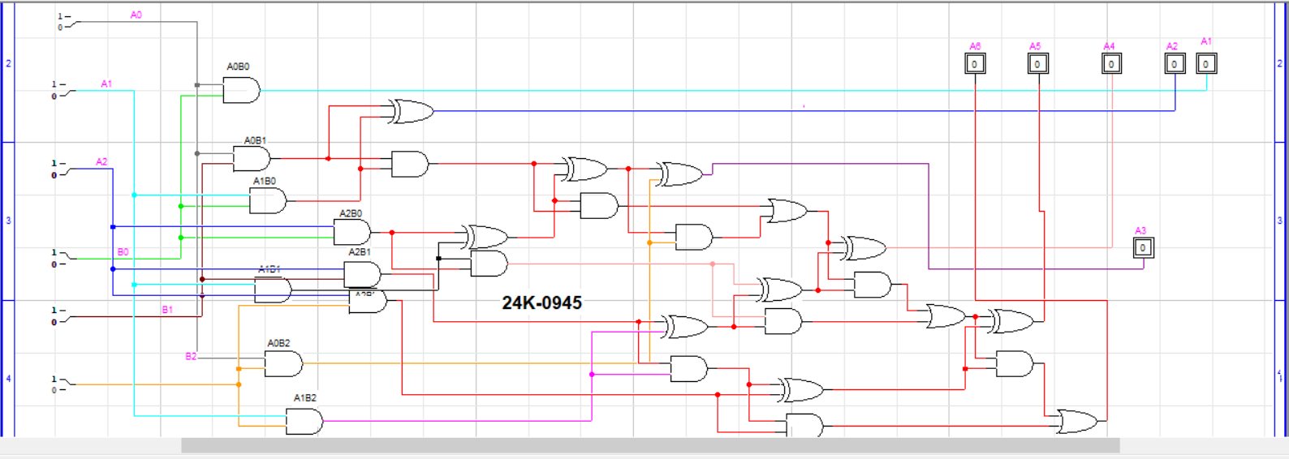

Qs 4
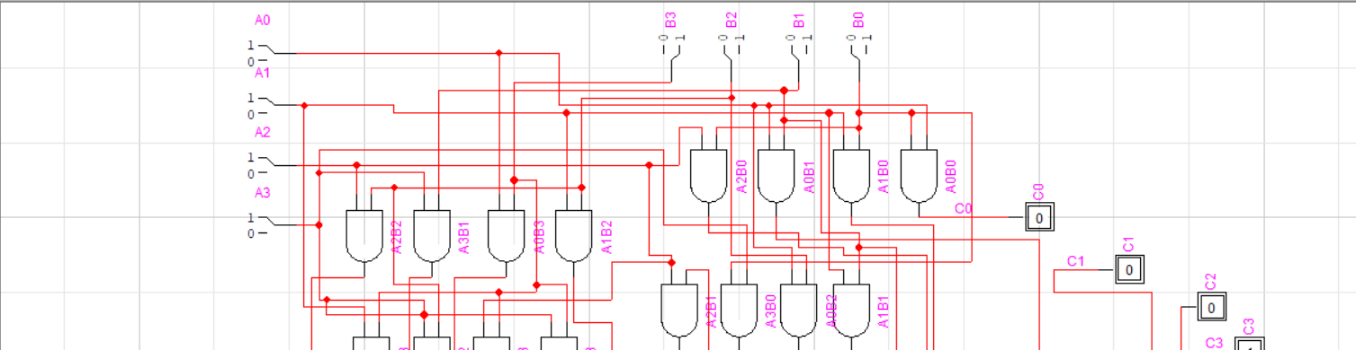
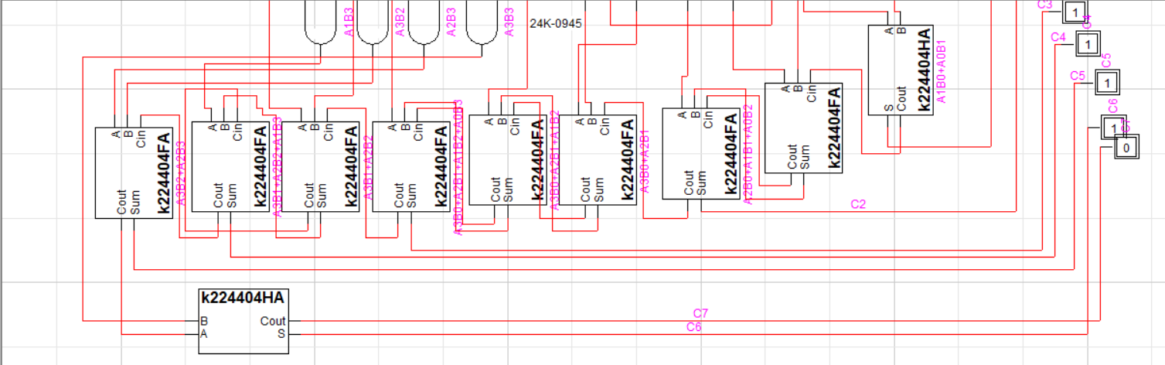

Qs 5

0945 + 24
= 0969

001110110001
+ 011000

= 0 0000 0011 1100 1001

